**Title of Your Abstract**

**(Times New Roman, Bold, 12 points, single line spacing)**

*Name Surname*, University, Department, City, Country*

*Name Surname, University, Department, City, Country*

*\** *Corresponding author: e-mail (Times New Roman, Italic, 10 points)*

***Keywords:*** keyword1, keyword2, keyword3.

**Introduction**

Authors are expected to comply with this template in the evaluation of abstracts. Abstracts should not exceed 1 (one) page. Abstracts can be in Turkish or English. If it will be in Turkish, it should be prepared using the template prepared for Turkish.

Abstracts should be prepared in A4 size (210mm x 297mm), with all margins of 2.5 cm. The main text should be written in Times New Roman, 11 font size, single-spaced justified and in a single column. At the beginning of the paragraph, a 0.60 cm indent should be made from the left. There should be no blank lines between paragraphs.

**Headings (Times New Roman, Bold, 11 points, centered)**

In your abstract that will not exceed one page, you can mention your study only under the title of ‘Abstract’ or you can use titles such as Introduction, Method and Results. Each new heading must be preceded by a blank line. Citations in the text should be given in the order of citation [1]. Each study given in the References should be mentioned in the text. References should be written in accordance with the writing style under the heading of References [2]. The results of the study should also be included in the abstract in a concise and understandable manner.

Tables, figures and equations can be added to the abstract. Tables should be in the format shown in Table 1 and figures should be in the format shown in Figure 1. While the titles of the tables are above the tables, the titles of the figures should be below the figures. One line space should be left after tables and figures. Tables and figures should be mentioned in the text [3].

Table 1. Findings

|  |  |  |  |
| --- | --- | --- | --- |
| Method | Sensitivity | Specificity | Accuracy |
| 1 | 0.98 | 0.89 | 0.95 |
| 2 | 0.87 | 0.76 | 0.83 |
| 3 | 0.67 | 0.43 | 0.75 |

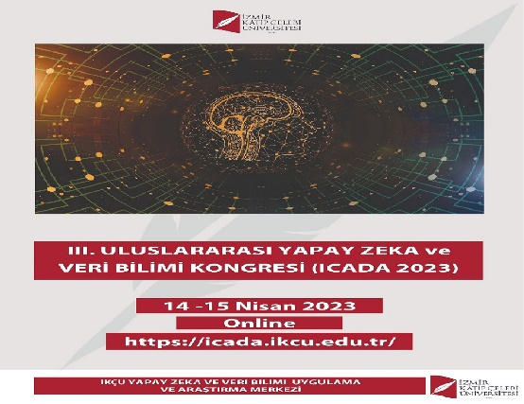

Figure 1. Icada2023

**References**

1. Collin, A.B. and Fake, D.E., “In Situ Studies of Wear Process”, ASME J. Tribology, 120, 3, 1995, 513-519.
2. Randles, S.J., “Formulation of Environmentally Acceptable Lubricants”, 49th STLE Annual Meeting, May 1-5, 1994, Pittsburgh.
3. Strunk, J.W., White E.B., “The elements of style”, 4th ed. New York: Longman 2000.